Barcode scanning program manual

File Name ：Barcode scanning program manual
File No. ：
Version No.：V1.0

Total 5 pages
(Including cover)

Compose dongqiwu
Review
Countersign

CILICO Microelectronics Ltd

Modify the record
File No. | Version No. | Composed By / Modified By | Compose / Modify Date | Modify Reason | Major change（Write the main Points） | Review By
 | V1.0 | Dong qiwu | 2017.03.15 | null | null | Shiliangyi
Note: When the file is prepared for the first time, write “None” on "Modify Reason" and "Major modifications columns

Contents
1 Introduction 3

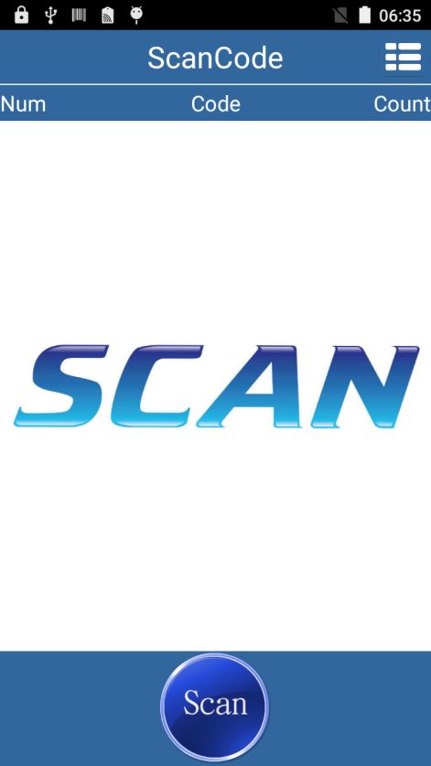
1 Introduction
1.1 Choose from all apps “ScanCode”
Program icon  ，Touch to open
the sample program,Program interface
as shown on the right:

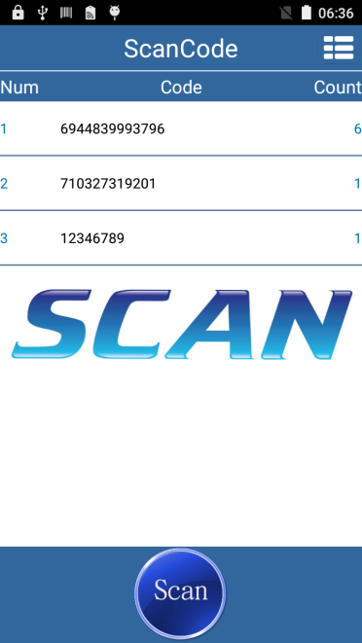
1.2 Touch“ Scan” Scan barcode，
can also be scanning by machines
left and right sides of the blue
buttons:

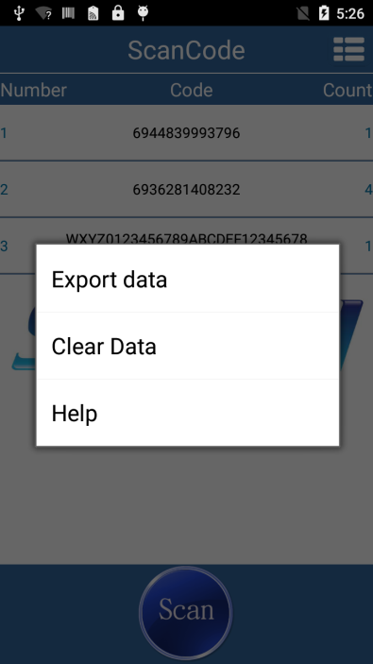
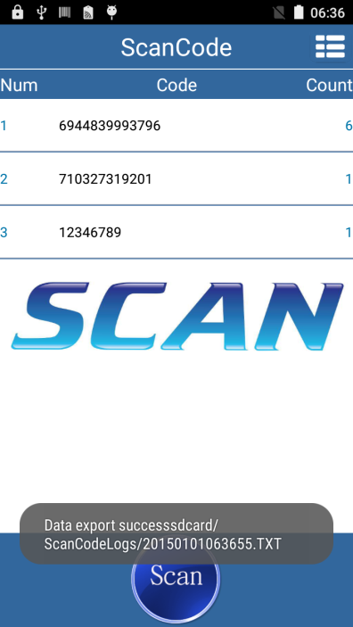
1.3 If you want To export the
data,please click the menu
Choose to export data, you can
save data to .txt,
File export path is:
Sdcard/ScanCodeLogs/

1.4 To clear the data, click the upper right corner of the menu button
Select to clear , you can clear the page data.

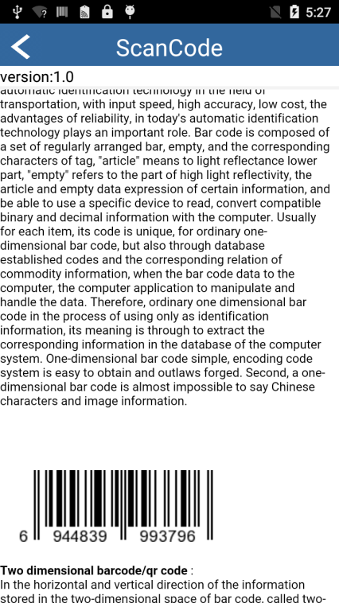
1.5 Help, click the upper right
corner of the menu button to select
Help, open the help page, It is
Basic knowledge about barcode.

